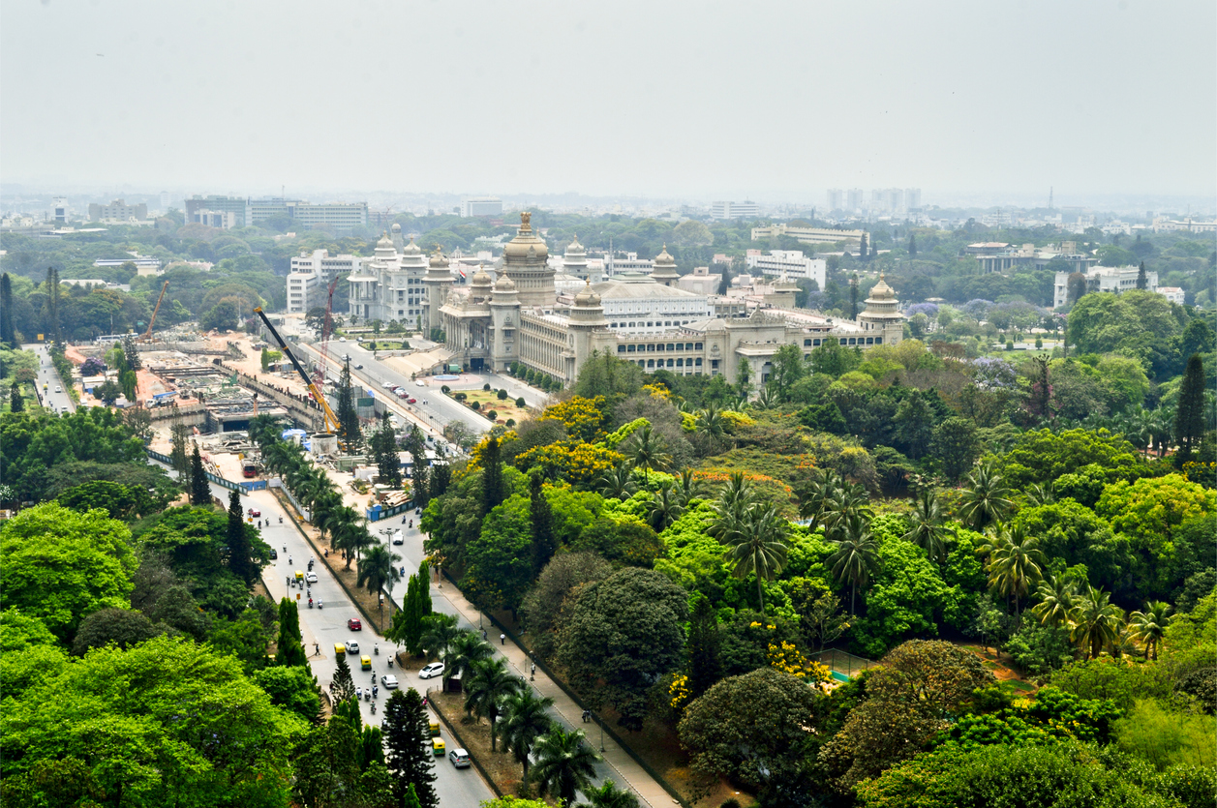

|  |
| --- |
| **The Battle of neighbourhood** |
| Capstone project report for Applied data science Certification |
| GAWALI.SAGAR@GMAIL.COM |

Contents

# 1. Introduction/Business Problem

Bengaluru is the capital of the Indian state of Karnataka. It has a population of more than 11 million, making it the third-most populous city and fifth-most populous urban agglomeration in India. Located in southern India on the Deccan Plateau, at a height of over 900 m (3,000 ft) above sea level, Bangalore is known for its pleasant climate throughout the year. The city is also widely regarded as the "Silicon Valley of India" (or "IT capital of India") because of its role as the nation's leading information technology (IT) exporter. Indian technological organisations such as ISRO, Infosys, Wipro, and HAL are headquartered in the city. A demographically diverse city, Bangalore is the second-fastest-growing major metropolis in India. Recent estimates of the metro economy of its urban area have ranked Bangalore either the fourth or fifth-most productive metro area of India. It is home to many educational and research institutions in India. Numerous state-owned aerospace and defence organisations, such as Bharat Electronics, Hindustan Aeronautics, and National Aerospace Laboratories are located in the city. The city also houses the Kannada film industry.

Owing to the factors mentioned above, there is a high demand for residential apartments/bungalows/villas, etc. (both rented/owned). And most of the time a newcomer in the city or someone who is trying to relocate within the city doesn't know which place is good for staying and which is not based on personal criteria. As part of this project, we would try to answer this question - Which area is suitable for different categories of people. We will also try to answer whether the area is good for staying for a bachelor's or families.

We can classify people into different categories. E.g. - someone who loves native food (i.e Indian Food, or western food), someone who prefers other sorts of entertainment, gym and fitness center, etc.

# 2. Data:

To answer the question raised in section, we will need the following set of data:

* Classification of areas of Bengaluru city into smaller area i.e. ward (a ward is an administrative unit of the city region;)
* Venue data (Malls, market, Supermarket, Parks, Schools, recreational activities, restaurants)

We will use the following sources for the above-mentioned data categories

1. Ward data: https://opencity.in/data/bbmp-wards

Sample:

|  |  |  |  |  |  |  |
| --- | --- | --- | --- | --- | --- | --- |
| Ward No | Ward Name | BBMP Zone Name | BBMP Division | BBMP Sub Division | Assembly constituency | MP Constituency |
| 1 | Kempegowda Ward | Yelahanka | Yelahanka | Yelahanka | Yelahanka | Chikballapur |
| 2 | Chowdeswari Ward | Yelahanka | Yelahanka | Yelahanka | Yelahanka | Chikballapur |
| 3 | Atturu | Yelahanka | Yelahanka | Yelahanka | Yelahanka | Chikballapur |
| 4 | Yelahanka Satellite Town | Yelahanka | Yelahanka | Yelahanka | Yelahanka | Chikballapur |
| 5 | Jakkuru | Yelahanka | Byatarayanapura | Byatarayanapura | Byatarayanapura | Bangalore North |
| 6 | Thanisandra | Yelahanka | Byatarayanapura | Byatarayanapura | Byatarayanapura | Bangalore North |
| 7 | Byatarayanapura | Yelahanka | Byatarayanapura | Byatarayanapura | Byatarayanapura | Bangalore North |
| 8 | Kodigehalli | Yelahanka | Byatarayanapura | Byatarayanapura | Byatarayanapura | Bangalore North |
| 9 | Vidyaranyapura | Yelahanka | Byatarayanapura | Vidyaranyapura | Byatarayanapura | Bangalore North |
| 10 | Dodda Bommasandra | Yelahanka | Byatarayanapura | Vidyaranyapura | Byatarayanapura | Bangalore North |

1. Venue Data: Foursquare APIs

|  |  |  |  |  |  |  |  |
| --- | --- | --- | --- | --- | --- | --- | --- |
|  | Ward Name | Ward Latitude | Ward Longitude | Venue | Venue Latitude | Venue Longitude | Venue Category |
| 0 | Kempegowda Ward | 12.9564316 | 77.5741194 | Brahmins Coffee Bar | 12.95398336 | 77.5688621 | Breakfast Spot |
| 1 | Kempegowda Ward | 12.9564316 | 77.5741194 | VB Bakery | 12.95168678 | 77.57712392 | Bakery |
| 2 | Kempegowda Ward | 12.9564316 | 77.5741194 | Food Street | 12.9509559 | 77.57779773 | Snack Place |
| 3 | Kempegowda Ward | 12.9564316 | 77.5741194 | Hari Super Sandwich | 12.94906313 | 77.57493508 | Sandwich Place |
| 4 | Kempegowda Ward | 12.9564316 | 77.5741194 | Bangalore City Institute | 12.9569247 | 77.57291529 | General Entertainment |
| 5 | Kempegowda Ward | 12.9564316 | 77.5741194 | Karnataka Bhel House | 12.95941243 | 77.56726435 | Fast Food Restaurant |

We will be using Venue Category to drive analysis.